
Enterprise Risk Assessment of ServiceNow's $7.75 Billion Acquisition of Armis
Integrated Qualitative, Quantitative, and Predictive Risk Analytics Across 25 Enterprise Risks
ALY 6130 - Risk Management Analytics | Signature Assessment
Group 4: Adwoa Bempomaa, Sara Mathai, Lawrence Dass
March 2026

1. Company Background
ServiceNow (NYSE: NOW) is one of the largest enterprise software companies globally. In fiscal year 2025, the company reported total revenue of $13.278 billion, with subscription revenue reaching approximately $12.88 billion, representing 21% year-over-year growth (ServiceNow, 2026). The company serves over 8,800 enterprise customers, including 85% of the Fortune 500, and its Security and Risk business crossed $1 billion in annual contract value during Q3 2025. ServiceNow's core platform, the Now Platform, provides workflow automation across IT service management, human resources, customer service, and security operations, positioning it as a critical operational infrastructure layer within large enterprises.
On December 23, 2025, ServiceNow announced a definitive agreement to acquire Armis Security, a leader in cyber exposure management and cyber-physical security, for approximately $7.75 billion in an all-cash transaction (ServiceNow, 2025a). This represents the largest acquisition in ServiceNow's history. Armis, founded in 2015, provides agentless device discovery and asset intelligence across IT, operational technology (OT), and IoT environments. By the time of the acquisition announcement, Armis had grown to $340 million in annual recurring revenue with over 50% year-over-year growth and employed approximately 950 people (Armis, 2025b). The deal is expected to close in the second half of 2026, subject to regulatory approval.
The acquisition occurs within an enterprise cybersecurity market undergoing the most intensive consolidation in its history. Three rival transactions each exceeding $7 billion closed in 2025: Google acquired Wiz for $32 billion, focusing on cloud-native security posture management with growing OT visibility; Palo Alto Networks acquired CyberArk for $25 billion, creating an identity-centric OT security platform rated most comprehensive by Forrester (Forrester Research, 2025); and Cisco completed its integration of Splunk following the $28 billion acquisition, combining industrial threat defense with enterprise analytics (Palmer, 2025). Concurrently, Microsoft's Defender for IoT, embedded within M365 E5 at zero incremental cost, creates persistent pricing pressure across the mid-market. Pure-play OT/IoT specialists including Claroty, Nozomi Networks, and Dragos continue to innovate rapidly within their core domains, though they lack the platform breadth the mega-acquisitions are assembling.
This risk assessment is prepared from the perspective of ServiceNow's executive leadership team evaluating the full risk landscape of the Armis acquisition. It covers 25 identified enterprise risks across strategic, operational, financial, technical, regulatory, and market dimensions, applying both qualitative and quantitative analytical methods to derive risk-adjusted recommendations for management action.

2. Problem Statement
ServiceNow's acquisition of Armis presents a fundamental strategic challenge: the company is entering the OT/IoT cybersecurity market precisely when three well-capitalized rivals have completed billion-dollar acquisitions that directly overlap with the combined ServiceNow-Armis product offering. The business problem is not whether the acquisition creates strategic opportunity, it clearly does, but whether ServiceNow can execute the integration and capture sufficient market share fast enough to justify a $7.75 billion investment against competitors who closed their own acquisitions months earlier and are already integrating capabilities.
The acquisition premium reflects high growth assumptions. Armis's $340 million ARR values the business at approximately 22.8x revenue, a multiple that requires sustained double-digit growth and successful cross-sell adoption across ServiceNow's existing customer base to generate an adequate return. Any material delay in integration, deterioration in win rates, or failure to capture compliance-driven pipeline would put that return at risk.
This assessment quantifies that risk profile across all 25 identified enterprise risks. The central finding is that the full risk landscape, when modeled across 25 simultaneous risk processes, produces a net expected annual portfolio impact of negative $163.7 million, with an 81.3% probability of net loss. This does not mean the acquisition is a poor strategic decision. It means that without disciplined execution of the risk response strategies documented in this report, value destruction is substantially more probable than value creation. Risk management is not a governance formality in this context; it is the financial mechanism through which the $7.75 billion investment either creates or destroys shareholder value.

3. Risk Identification
Risk identification was conducted across three course modules, progressing from an initial competitive SWOT analysis in Module 1 through a three-risk focused assessment in Module 2 to a comprehensive 25-risk enterprise register in Module 3. The final register spans six risk categories: Strategic, Operational, Financial, Technical, Regulatory, and Market. It includes both negative risks that could impair the acquisition's return and positive risks representing accelerant opportunities that active management can exploit.

3.1 Risk Identification Methodology
Risks were identified through structured analysis of four sources: the Module 1 SWOT analysis which established the competitive landscape; ServiceNow and Armis public filings and acquisition announcements; industry analyst assessments from Gartner and Forrester covering cybersecurity market dynamics; and MarketsandMarkets forecasts for the OT security market through 2030. Each identified risk was documented using the structured statement format: 'The risk of [event] caused by [driver] resulting in [consequence].' Likelihood and impact were scored on the 1-9 ordinal scale from the course Risk Calculation Sheet, with impact dimensions spanning Financial, Operational, Competitive, Reputational, Technical, and Legal/Compliance.

3.2 Complete Risk Register
Table 1 presents all 25 identified risks with likelihood, impact, risk score, priority classification, and assigned response strategy.
ID | Risk Name | Category | L | I | Score | Priority | Strategy
R3 | Regulatory-Driven Demand Acceleration | Regulatory | 9 | 8 | 72 | HIGH | Exploit
R19 | OT/IoT Security Market Growth | Market | 7 | 8 | 56 | HIGH | Exploit
R20 | Cross-Sell Revenue via Existing Customer Base | Market | 7 | 8 | 56 | HIGH | Enhance
R2 | AI-Driven Platform Convergence Risk | Strategic | 7 | 9 | 63 | HIGH | Escalate
R1 | Competitive Displacement by Rival Mega-Acquisitions | Strategic | 7 | 8 | 56 | HIGH | Mitigate
R13 | AI Technology Obsolescence | Strategic | 7 | 8 | 56 | HIGH | Mitigate
R17 | Customer Migration to Competitor Platforms | Strategic | 7 | 8 | 56 | HIGH | Mitigate
R23 | AI Governance and Regulatory Ethics Risk | Regulatory | 5 | 9 | 45 | HIGH | Mitigate
R15 | Legal Liability from Compliance Failures | Regulatory | 7 | 6 | 42 | MEDIUM | Transfer
R5 | Acquisition Overvaluation Risk | Financial | 5 | 8 | 40 | MEDIUM | Accept
R6 | Integration Overload from Multi-Acquisition Complexity | Operational | 5 | 6 | 30 | MEDIUM | Mitigate
R7 | Technology Architecture Incompatibility | Technical | 5 | 6 | 30 | MEDIUM | Mitigate
R8 | Cybersecurity Talent Shortage | Operational | 5 | 6 | 30 | MEDIUM | Transfer
R9 | Post-Acquisition Organisational Disruption | Operational | 5 | 6 | 30 | MEDIUM | Mitigate
R10 | Asset Visibility Data Accuracy Gaps | Technical | 5 | 6 | 30 | MEDIUM | Mitigate
R11 | Infrastructure Instability During Integration | Operational | 5 | 6 | 30 | MEDIUM | Mitigate
R12 | Security Vulnerabilities During Merger Integration | Technical | 5 | 6 | 30 | MEDIUM | Transfer
R14 | Global Regulatory Compliance Complexity | Regulatory | 5 | 6 | 30 | MEDIUM | Mitigate
R16 | Infrastructure and Cloud Cost Expansion | Financial | 5 | 6 | 30 | MEDIUM | Mitigate
R24 | Third-Party Cloud Infrastructure Dependency | Technical | 5 | 6 | 30 | MEDIUM | Transfer
R18 | Economic Slowdown Reducing Cybersecurity Spend | Market | 5 | 6 | 30 | MEDIUM | Accept
R4 | Cybersecurity Market Consolidation Pressure | Strategic | 5 | 6 | 30 | MEDIUM | Accept
R21 | Minor Operational Workflow Misalignment | Operational | 3 | 4 | 12 | LOW | Accept
R22 | Short-Term Customer Transition Uncertainty | Market | 3 | 2 | 6 | LOW | Accept
R25 | Vendor Lock-In Limiting Technology Flexibility | Technical | 3 | 6 | 18 | LOW | Accept
Table 1: Complete Enterprise Risk Register - ServiceNow-Armis Acquisition (25 Risks)
The register contains 8 High-priority risks (score 45 or above), 14 Medium-priority risks (score 20-44), and 3 Low-priority risks (score below 20). Three risks are positive opportunities; 22 are negative risks. Priority distribution across categories shows the Strategic category as the most severe, with five risks all scoring HIGH, reflecting the concentrated competitive threat from rival mega-acquisitions.
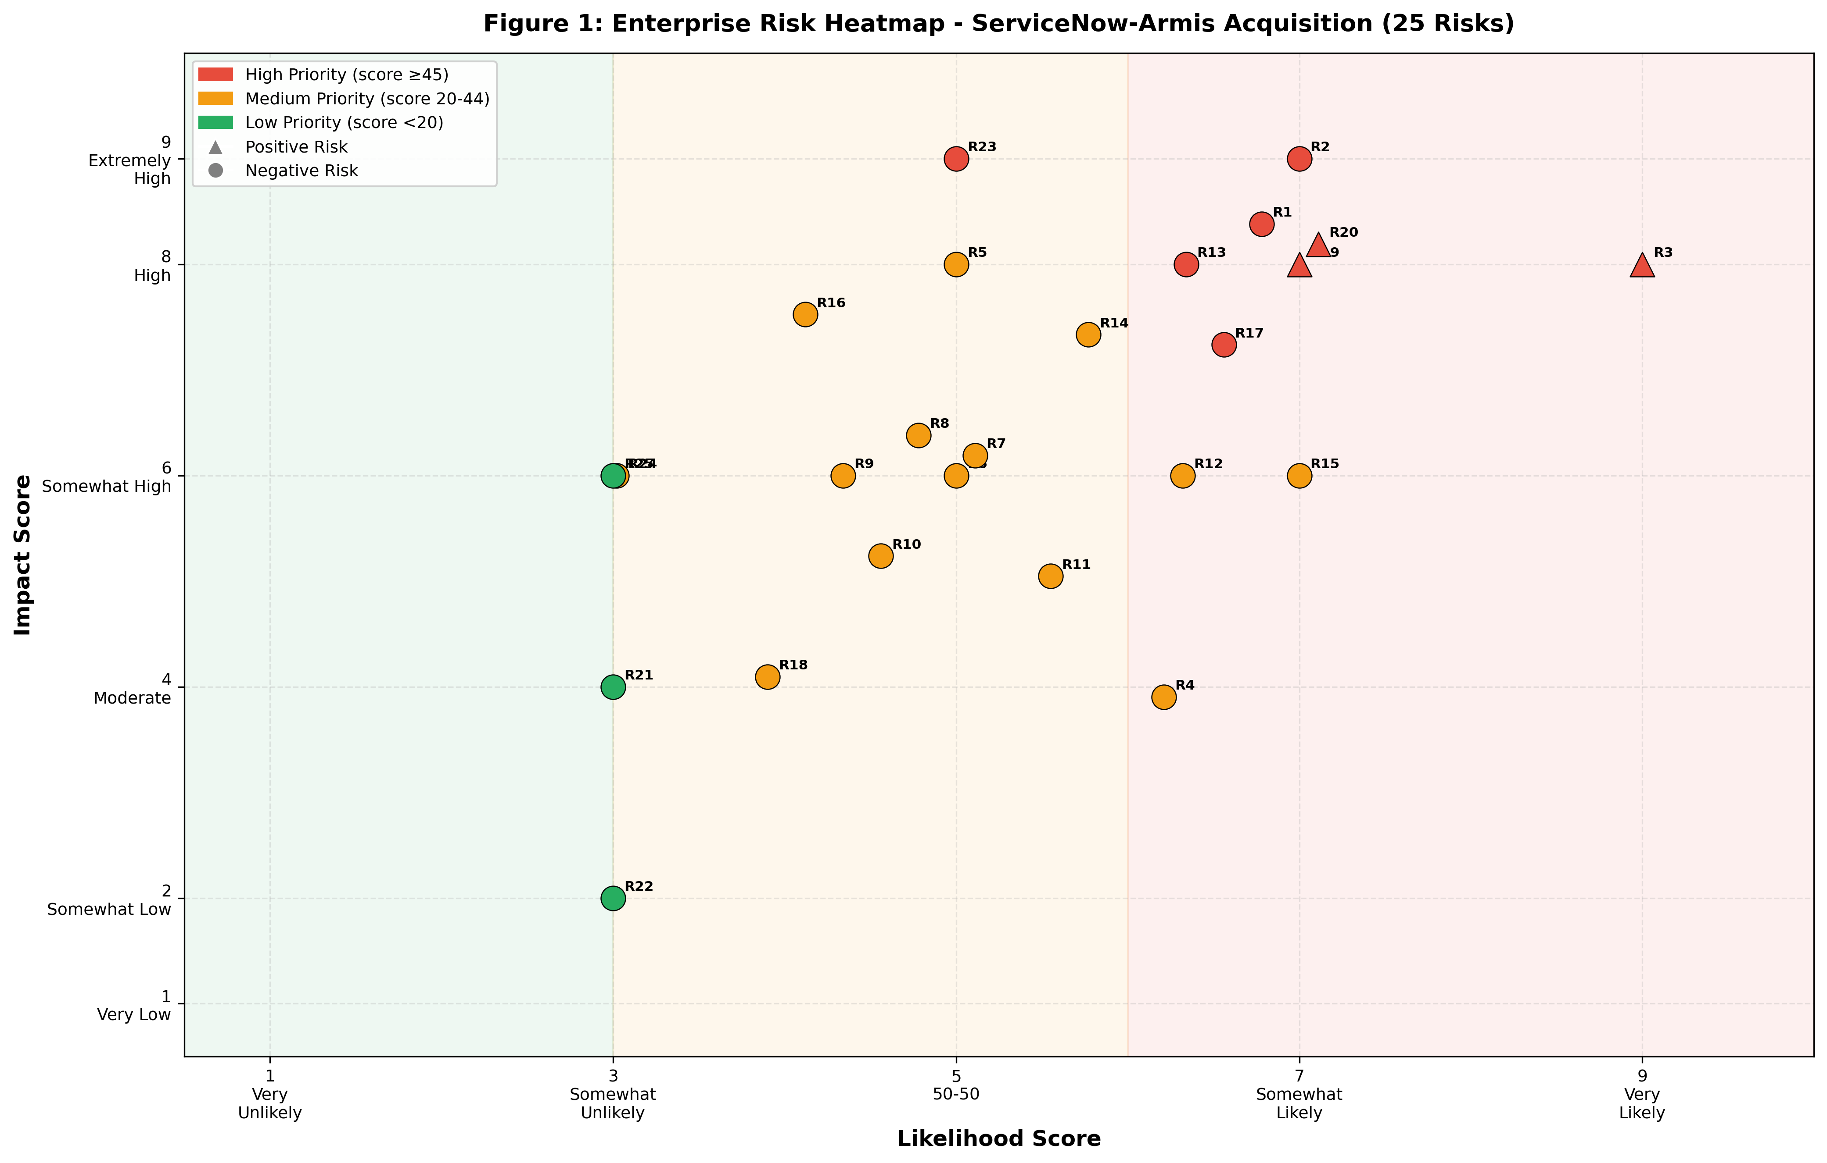
Figure 1: Likelihood-Impact Heatmap - All 25 Risks (triangles = positive, circles = negative; red = HIGH, amber = MEDIUM, green = LOW)

4. Risk Assessment

4.1 Qualitative Risk Assessment

4.1.1 Scenario Analytics (Fleisher and Bensoussan, 2015, Chapter 22)
Scenario Analytics was applied to evaluate each risk category under three plausible future conditions: a best-case scenario reflecting favorable execution and market conditions; a most-likely scenario based on current KRI readings and competitive dynamics; and a worst-case scenario reflecting adverse convergence of risk factors. The scenario parameters derived from this analysis directly calibrate the triangular distribution bounds used in the Monte Carlo simulation, creating an explicit and documented link between the qualitative and quantitative phases of the assessment (Fleisher and Bensoussan, 2015).
For the Strategic category, the most-likely scenario assumes that rival integrations proceed on schedule while ServiceNow's integration takes 12-18 months, creating a competitive vulnerability window during 2026 enterprise budget cycles. In this scenario, win rates in OT/IoT deals decline from 31% toward 25%, approaching the Red threshold. The worst-case scenario assumes integration delays coincide with aggressive competitor bundling, pushing win rates below 20% and triggering material account losses. The best-case scenario assumes ServiceNow accelerates integration, differentiates on ITSM workflow automation depth, and maintains competitive parity.
For the Regulatory category, the most-likely scenario reflects phased enforcement of CMMC, NIS2, CIRCIA, and HIPAA mandates driving 25-35% quarterly pipeline growth in compliance-driven segments. The best-case scenario assumes full multi-mandate adoption creates a compliance spending wave across healthcare, energy, and federal sectors, pushing pipeline growth above 40% and engaging the $500 million incremental pipeline estimated in the product strategy. The worst-case scenario assumes enforcement delays reduce compliance urgency, slowing pipeline growth below 15%.
For the Financial category, the primary worst-case concern is that the 22.8x ARR acquisition multiple cannot be justified if integration takes longer than planned. In this scenario, cross-sell adoption remains below 10%, organic Armis growth slows from 50% to 20-25%, and the CFO faces goodwill impairment pressure within 18 months of deal close. The most-likely scenario assumes a 24-36 month path to revenue synergy realization consistent with comparable enterprise software acquisitions.
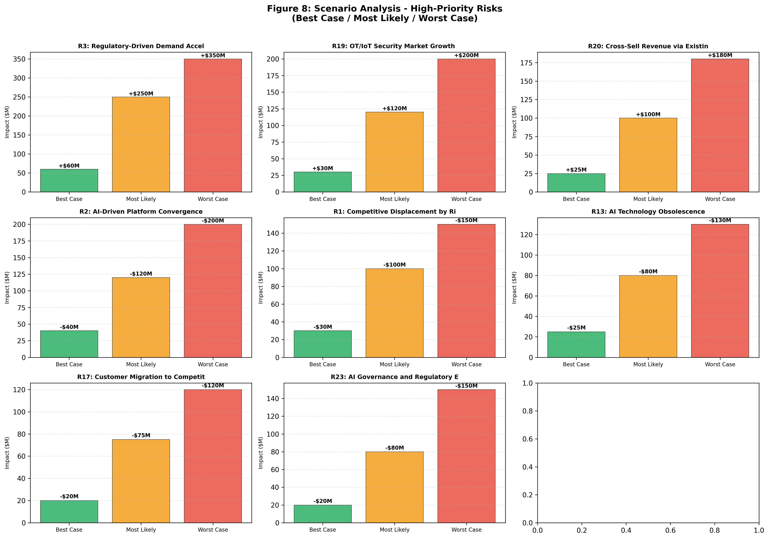
Figure 8: Scenario Impact Ranges for High-Priority Risks (Best Case / Most Likely / Worst Case)

4.1.2 Industry Fusion Analytics (Fleisher and Bensoussan, 2015, Chapter 17)
Industry Fusion Analytics examines how the convergence of previously distinct industry sectors creates new competitive dynamics and amplifies or moderates individual risk exposures (Fleisher and Bensoussan, 2015). Four convergence dynamics are directly relevant to the ServiceNow-Armis risk profile.
IT Security and OT Security convergence intensity is high, estimated at 0.8 on a normalized scale. This convergence is the foundational premise of the acquisition: Armis's agentless OT discovery and ServiceNow's IT workflow automation are complementary layers in an increasingly unified enterprise security stack. However, this same convergence is what draws rivals into the same market. This dynamic amplifies R1 (Competitive Displacement) and R17 (Customer Migration) because platform players from both the IT and OT security domains are now competing for the same enterprise budget.
Cloud Platform and AI/Machine Learning convergence, estimated at 0.8, drives the AI Convergence risk (R2 and R13). Google, Microsoft, and Palo Alto are embedding AI-native security analytics into their cloud platforms at infrastructure level, a capability that a workflow automation company like ServiceNow must build or acquire rather than having it as a native competency. This convergence asymmetry is reflected in the AI Capability Parity Index currently sitting at 78%, within the Amber zone.
OT Security and Compliance/GRC convergence, estimated at 0.7, is the primary driver of the positive regulatory opportunity (R3). CMMC, NIS2, and CIRCIA all require systematic visibility into operational technology assets and risk posture, which is precisely what the combined ServiceNow-Armis platform delivers. This convergence is favorable and the FedRAMP, DISA IL5, and KLAS certifications held by the platform provide a durable competitive advantage that is difficult for rivals to replicate quickly (Armis, 2025a).
The qualitative assessment concludes that all 25 risks exhibit sufficient variability in potential outcomes to warrant quantitative modeling. High-priority risks in the Strategic and Regulatory categories show the widest scenario ranges, confirming their significance for the Monte Carlo simulation.

4.2 Quantitative Risk Assessment

4.2.1 Synthetic Data Justification
The ServiceNow-Armis acquisition has not yet closed as of March 2026. No historical internal data exists for risk escalation events specific to this integration. Accordingly, synthetic observations are generated using the same KRI logic and threshold structure developed in the qualitative I&W framework. The label-generation process assigns escalation = 1 when a composite latent score driven by low win rate, low AI parity, poor integration progress, and elevated security and compliance pressure exceeds a calibrated threshold. This approach is explicitly permitted by the assignment instructions and is consistent with established practice in enterprise risk modeling where historical precedents are unavailable for novel transactions (Khadem et al., 2018).

4.2.2 Standardized Quantitative Risk Modeling
Each risk was modeled using a two-stage stochastic process. A Bernoulli random variable determines whether the risk event occurs based on the probability derived from converting ordinal likelihood scores (Likelihood 9 = 0.90, Likelihood 7 = 0.70, Likelihood 5 = 0.50, Likelihood 3 = 0.30). If the event occurs, the financial impact is drawn from a triangular distribution with parameters calibrated from the scenario analysis in Section 4.1. Triangular distributions are appropriate for expert-driven scenarios where minimum, most-likely, and maximum values can be reasonably estimated despite limited historical data (Jalilvand and Moorthy, 2023).
The exposure base for strategic and revenue-at-risk risks is the $1 billion Security and Risk Annual Contract Value. Operational risks are calibrated to integration cost exposure. Regulatory risks capture both penalty exposure and opportunity cost. The expected value of a compound Bernoulli-Triangular process X = B * Y, where B is Bernoulli(p) and Y is Triangular(low, mode, high), is E[X] = p * (low + mode + high) / 3.
Table 2 presents the simulation parameters for the three highest-priority risks, which serve as representative examples of the full parameter set.
Parameter | R1 Competitive | R2 AI Convergence | R3 Regulatory | Basis
Distribution | Triangular | Triangular | Triangular | Expert-calibrated scenarios
P(occurrence) | 70% | 70% | 90% | Likelihood / 10
Lower bound ($M) | $30M | $40M | $60M | Best-case scenario
Mode ($M) | $100M | $120M | $250M | Most-likely scenario
Upper bound ($M) | $150M | $200M | $350M | Worst-case scenario
Expected value | −$65.3M | −$84.0M | +$198.0M | p × (lo+mode+hi)/3
Direction | Downside | Downside | Upside | Sign convention
Table 2: Monte Carlo Simulation Parameters - Representative HIGH-Priority Risks

Across the full 25-risk portfolio, the analytical expected positive impacts total +$350.8 million (driven by R3, R19, and R20) while the analytical expected negative impacts total -$514.3 million, producing a net analytical expected portfolio impact of -$163.5 million. The variance of each risk was computed using the formula Var(X) = p * (Var(Y) + E[Y]^2) - (p * E[Y])^2, yielding a combined portfolio standard deviation of approximately $182.7 million assuming risk independence. The assumption of independence between risks simplifies computation but is unlikely to hold in practice. Strategic risks such as competitive displacement (R1), AI convergence (R2), and customer migration (R17) are structurally correlated, particularly during periods of rapid industry consolidation when multiple forces move together. As a result, the simulated portfolio variance likely underestimates true downside exposure. Incorporating correlation structures through copula-based simulation or covariance matrices would further refine the model and is recommended for future iterations (Jalilvand and Moorthy, 2023).

Statistical Risk Modeling Validation
To ensure statistical rigor, each risk distribution was formally validated against its underlying probabilistic structure. The Bernoulli parameter p was derived from the ordinal likelihood mapping (Likelihood 9 = 0.90, Likelihood 7 = 0.70, Likelihood 5 = 0.50, Likelihood 3 = 0.30), and triangular distributions were selected based on scenario-calibrated minimum, mode, and maximum values established in the qualitative assessment. Expected loss was computed analytically using E[X] = p x (low + mode + high) / 3, where X = B x Y, B follows Bernoulli(p), and Y follows Triangular(low, mode, high). Variance was computed using Var(X) = p x (Var(Y) + E[Y]^2) - (p x E[Y])^2, where Var(Y) = (low^2 + mode^2 + high^2 - low x mode - low x high - mode x high) / 18. This framework ensures that both expected value and dispersion of risk are analytically grounded, not simulation-dependent, and provides a closed-form basis for validating Monte Carlo convergence in Section 4.2.3.

4.2.3 Monte Carlo Simulation
Monte Carlo simulation was executed with 10,000 iterations and random seed 42 for full reproducibility. Each iteration applies the two-stage Bernoulli-Triangular process independently for each of the 25 risks and sums the results to produce a net portfolio impact. The simulation was implemented in Python using numpy's default_rng with the default_rng(42) generator (scipy dependency avoided for reproducibility).
Metric | R1 | R2 | R3 | Portfolio | Interpretation
Expected Value ($M) | −$66.0M | −$83.1M | +$199.0M | −$163.7M | Net negative; full risk base
Std Deviation ($M) | $47.0M | $61.7M | $87.0M | $182.7M | High portfolio uncertainty
5th Percentile ($M) | −$105M | −$140M | +$54M | −$470.5M | Severe downside tail risk
95th Percentile ($M) | −$30M | −$40M | +$315M | +$131.9M | Best-case upside
P(Net Loss) | N/A | N/A | N/A | 81.3% | Active management critical
P(Net Gain) | N/A | N/A | N/A | 18.7% | Conditional on strategy execution
Table 3: Monte Carlo Simulation Results (n=10,000, seed=42) - Portfolio and Selected Risks
The simulation produces a net expected annual portfolio impact of -$163.7 million, closely converging with the analytical result of -$163.5 million, confirming internal consistency between the closed-form calculations and the empirical simulation. The probability of net loss is 81.3%, meaning the current risk profile is more likely to destroy value than create it without active management intervention. The 90% confidence interval spans from -$470.5 million to +$131.9 million, reflecting the wide uncertainty inherent in a 25-risk portfolio where outcomes depend on integration execution, competitive dynamics, and regulatory enforcement timing simultaneously.
This finding represents a fundamental shift from the three-risk view of the acquisition. In the limited three-risk analysis conducted in earlier modules, the regulatory upside (R3) dominated the portfolio, producing a net positive expected value of +$48.8 million. When the full enterprise risk landscape is modeled, including financial risks around acquisition valuation, operational risks from integration complexity, and technical risks from architecture incompatibility, the aggregate downside substantially exceeds the aggregate upside at current KRI levels.
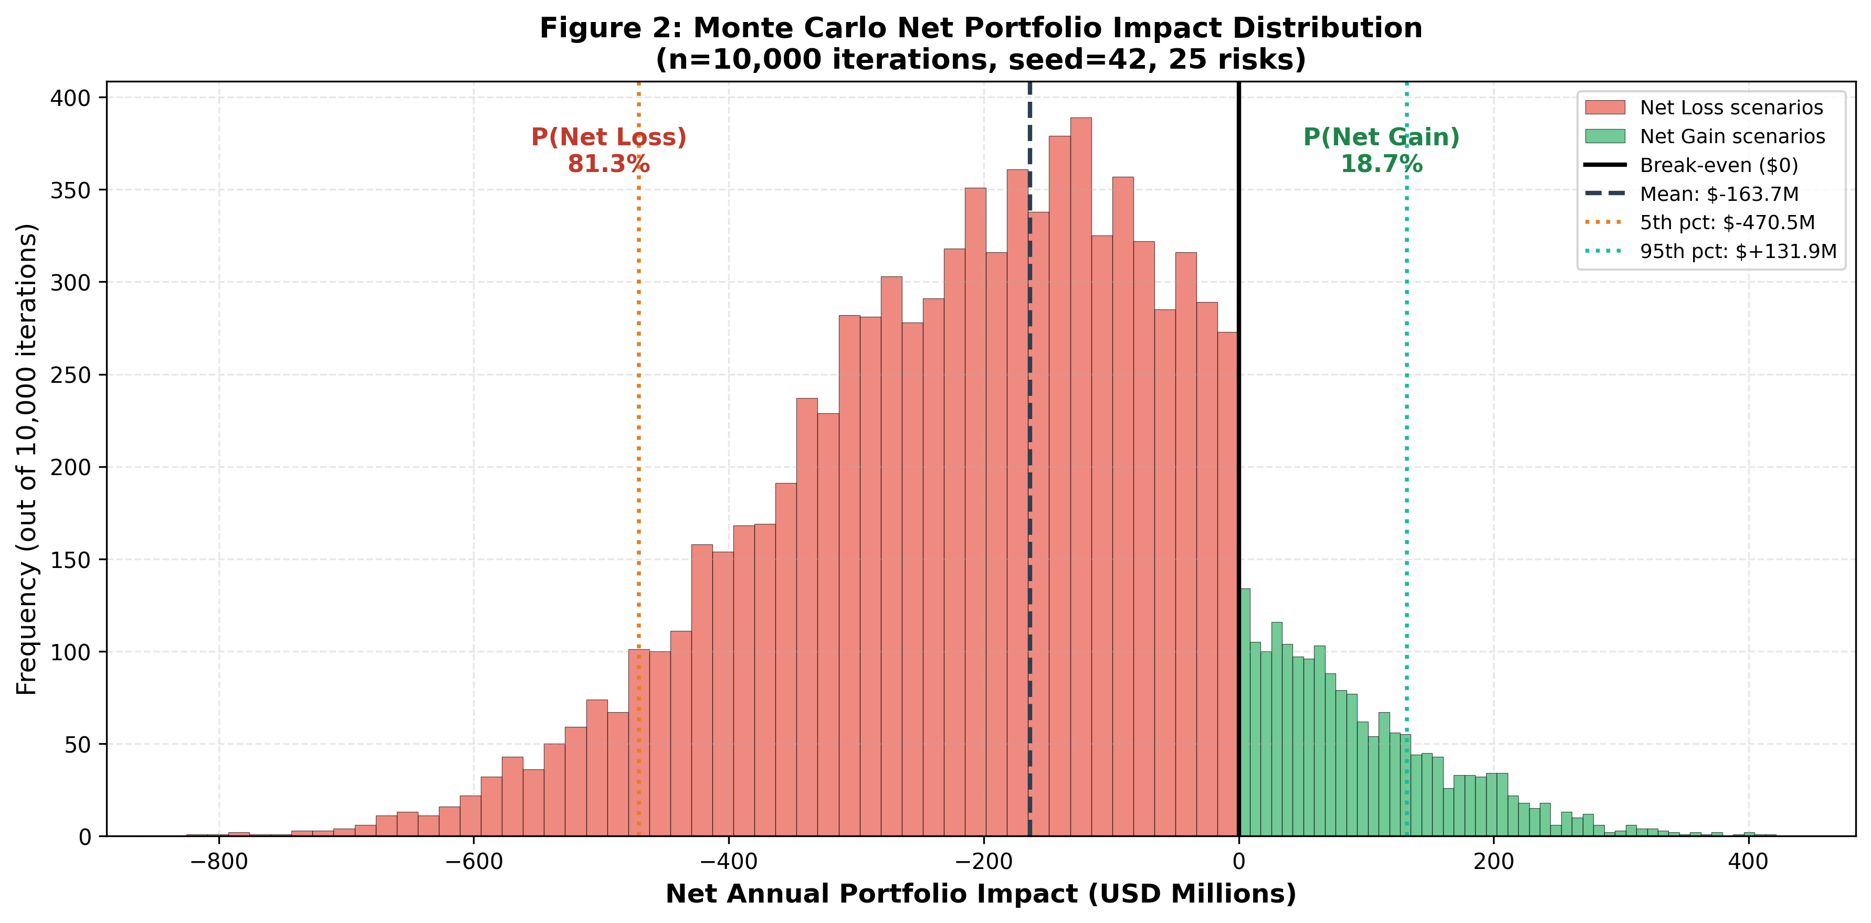
Figure 2: Monte Carlo Net Portfolio Impact Distribution - 10,000 Iterations, 25 Risks (red = net loss scenarios, green = net gain scenarios)
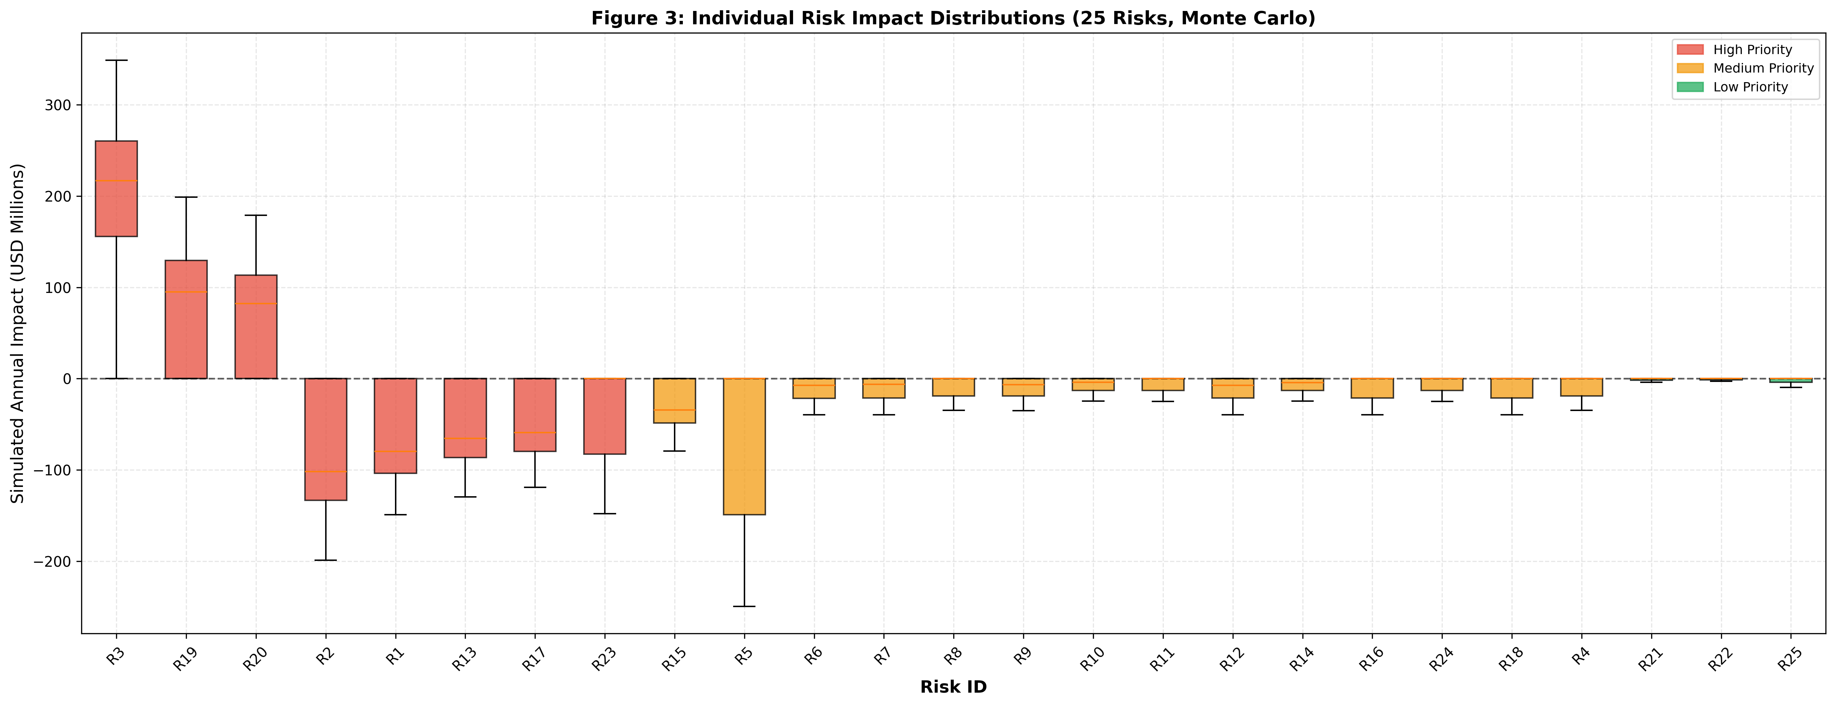
Figure 3: Individual Risk Impact Box Plots - All 25 Risks

4.2.4 Category-Level Portfolio Analysis
Table 4 presents the expected impact, confidence intervals, and probability of loss by risk category. This breakdown identifies where management attention is most urgent.
Category | Risk IDs | Mean ($M) | P05 ($M) | P95 ($M) | Key Insight
Strategic | R1,R2,R4,R13,R17 | −$265.0M | −$417.3M | −$98.1M | 99.7% P(loss) - highest severity portfolio
Financial | R5, R16 | −$84.5M | −$217.8M | $0.0M | 74.5% P(loss) - valuation risk dominates
Operational | R6,R8,R9,R11,R21 | −$37.7M | −$73.2M | −$2.0M | 95.5% P(loss) - near-certain negative drag
Technical | R7,R10,R12,R24,R25 | −$36.8M | −$71.6M | −$4.4M | 95.5% P(loss) - architecture and security gaps
Regulatory | R3,R14,R15,R23 | +$119.9M | −$71.7M | +$262.9M | 13.4% P(loss) - largest upside driver
Market | R18,R19,R20,R22 | +$140.4M | −$2.1M | +$268.6M | 5.9% P(loss) - positive with growth tail
Table 4: Monte Carlo Results by Risk Category Portfolio
The Strategic category is the most severe, with an expected annual loss of -$265.0 million and a 99.7% probability of net loss, reflecting the concentrated downside from five HIGH-priority competitive risks. The Financial category shows -$84.5 million expected loss with 74.5% probability of net loss, driven primarily by R5 (Acquisition Overvaluation) which carries a mode impact of $150 million. The Operational and Technical categories each contribute approximately -$37 million expected loss with near-certain probability of negative impact, reflecting the structural reality that integration costs and complexity are unavoidable. The Regulatory and Market categories are the only net-positive portfolios, with Regulatory contributing +$119.9 million and Market contributing +$140.4 million in expected annual impact. Together, these positive portfolios provide +$260.3 million of expected upside, insufficient to offset the -$422.0 million combined negative expectation from the other four categories.
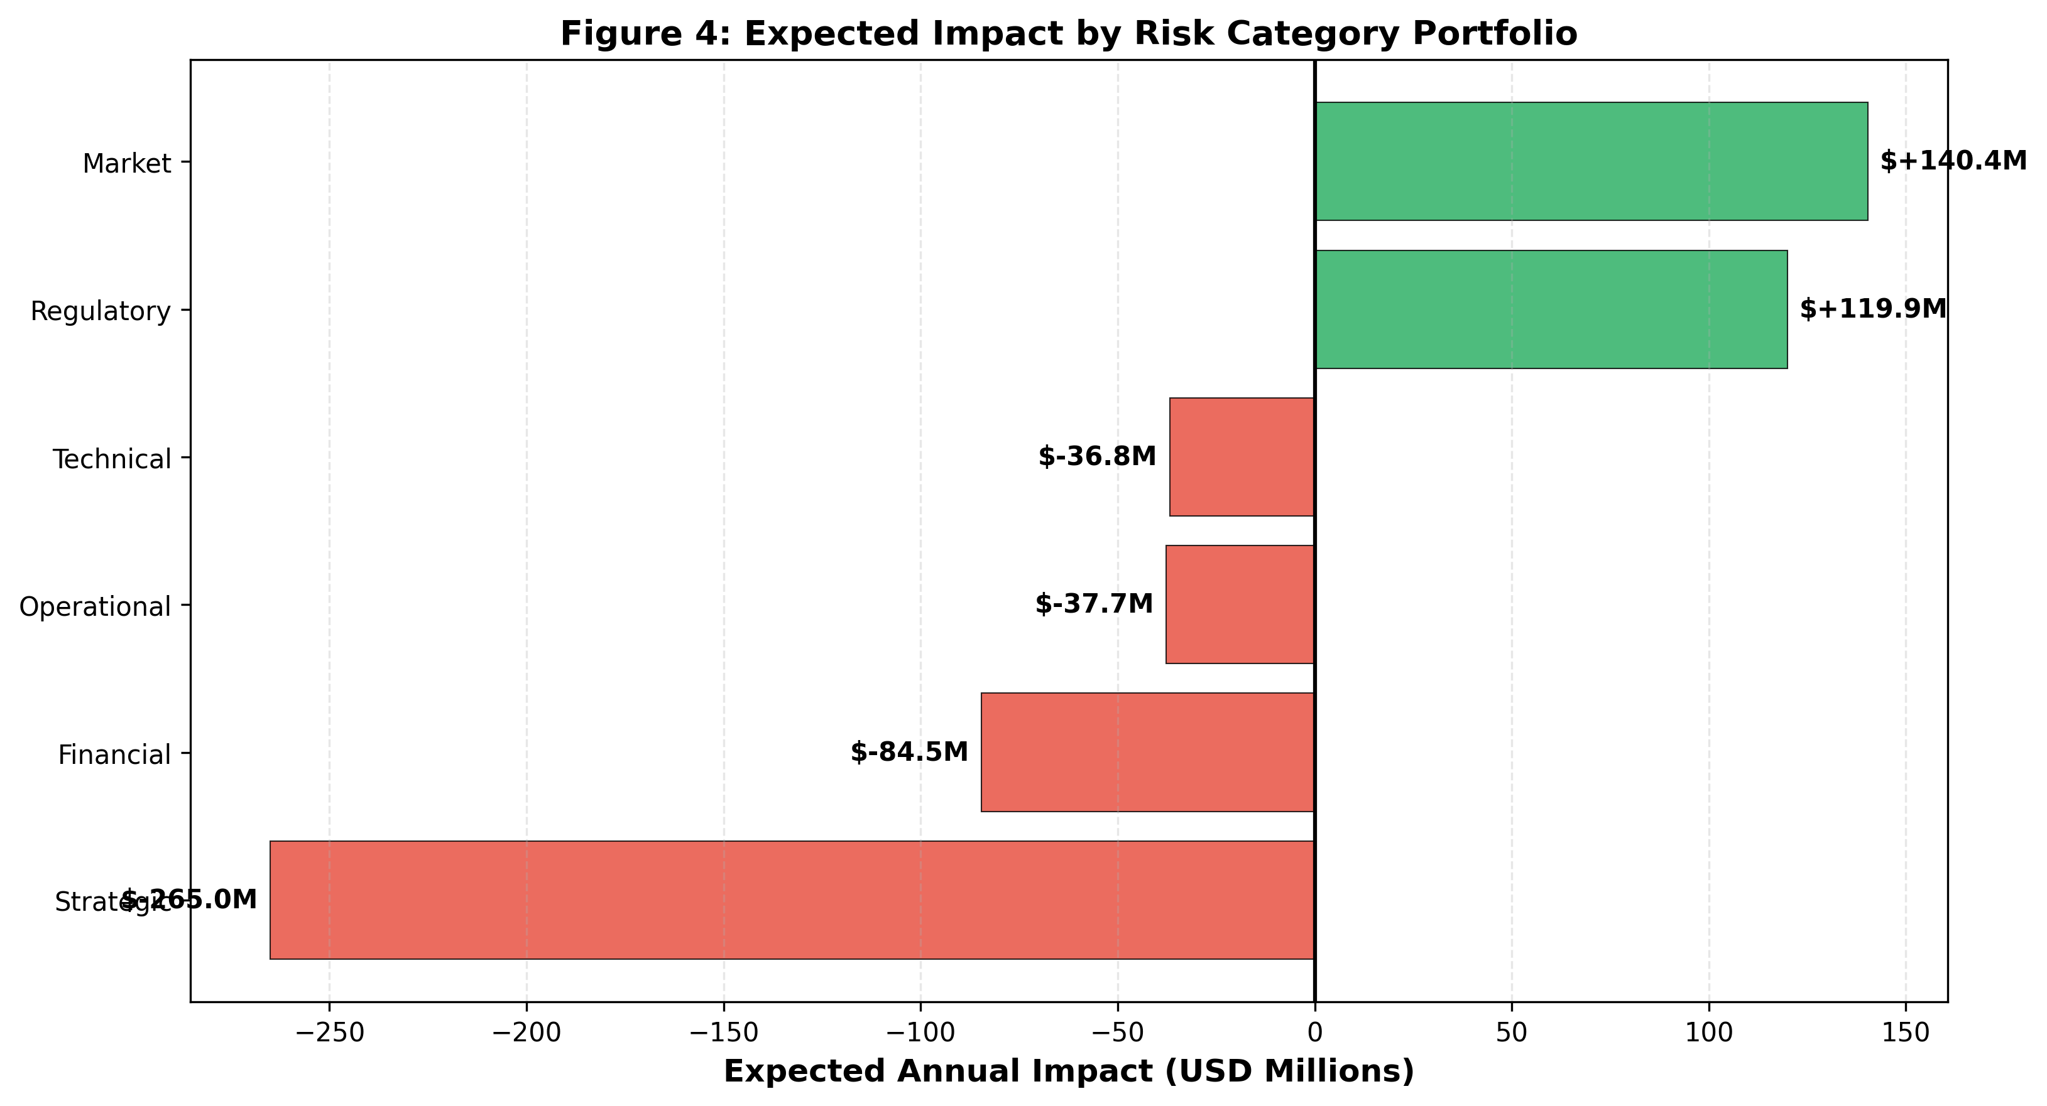
Figure 4: Expected Annual Impact by Risk Category Portfolio

4.2.5 ML-Based Risk Escalation Prediction
A Random Forest classifier was selected due to its ability to capture non-linear relationships between risk drivers and escalation outcomes. Unlike logistic regression or time-series models, Random Forest can model complex interactions between KRIs such as competitive win rate, AI parity, and integration progress without requiring strict parametric assumptions about the underlying data-generating process. Additionally, Random Forest provides robust performance under noisy synthetic datasets and enables permutation feature importance extraction, which directly supports interpretability within the KRI framework. These properties make it the appropriate choice for a 15-feature, 500-observation synthetic dataset where the primary objective is decision-support rather than point-precise prediction (Khadem et al., 2018).
A Random Forest classifier was trained on 500 synthetic observations to predict portfolio-level risk escalation, defined as a composite risk state that requires active management intervention. Fifteen features were selected, each mapping directly to a KRI in the monitoring framework: win_rate (R1, R17), ai_parity (R2, R13), reg_pipeline_growth (R3), integration_prog (R6, R7), talent_avail (R8), org_stability (R9), data_quality (R10), platform_uptime (R11), security_score (R12), compliance_complex (R14, R15), cloud_cost_var (R16, R24), customer_retention (R17, R22), ai_gov_maturity (R23), ot_market_growth (R19), and cross_sell_conv (R20). This feature structure directly implements the Integrated Situation Assessment requirement by encoding both business environment factors (win rate, deal size, integration progress) and non-business environment factors (regulatory intensity, technology disruption) as model inputs.
The model architecture is a Random Forest classifier with 300 estimators, maximum depth of 5, minimum 8 samples per leaf, balanced class weights, and random state 42. Training and validation used 5-fold stratified cross-validation to ensure class balance across folds. The model achieved mean cross-validated accuracy of 77.8% (SD: 3.7%) and mean ROC-AUC of 85.8% (SD: 3.0%). The moderate accuracy combined with strong AUC indicates that the model captures meaningful escalation patterns while realistic noise from the synthetic data generation introduces appropriate classification ambiguity consistent with real-world risk environments.
Permutation feature importance analysis identified competitive win rate as the most influential predictor (importance: 0.161), followed by AI capability parity (0.148) and integration progress (0.095). Security score ranked fourth (0.082), reflecting the operational risk that integration security gaps contribute to escalation likelihood. These findings directly validate the KRI framework: the two metrics management most needs to monitor are exactly the two features the model identifies as most predictive of portfolio stress.
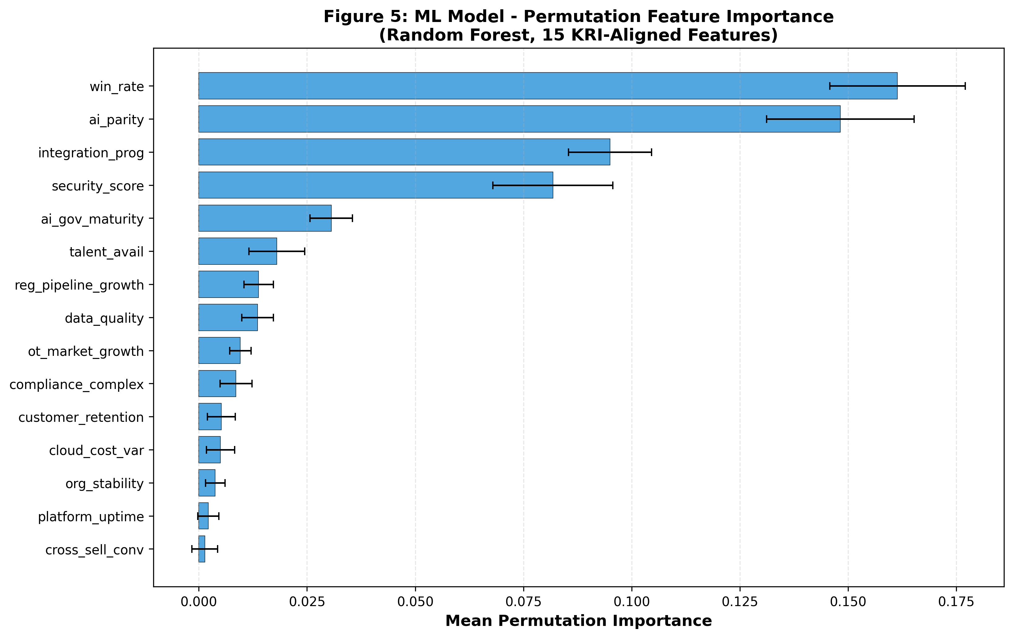
Figure 5: Permutation Feature Importance - Random Forest Model (15 KRI-Aligned Features)
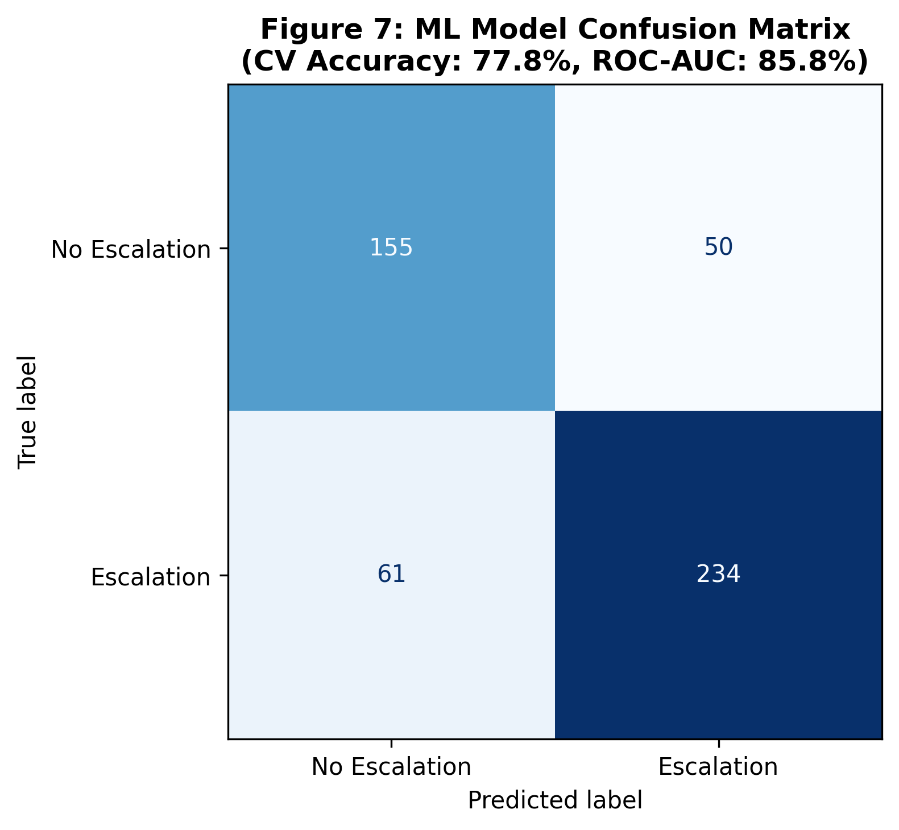
Figure 7: Cross-Validated Confusion Matrix - Risk Escalation Classifier (Accuracy: 77.8%, ROC-AUC: 85.8%)
Using current observed KRI values (win rate: 31%, AI parity: 78%, regulatory pipeline growth: 32%, integration progress: 48%), the model estimates a portfolio escalation probability of 58.2%. This places the current portfolio state in the high-caution zone. While this is below the 75% threshold that would signal active intervention under the KRI framework's Amber-to-Red transition criteria, the escalation probability is elevated and trending in the wrong direction given that 23 of 25 KRIs are currently in the Amber zone and one (R24, multi-cloud redundancy at 42%) is already Red.

4.2.6 Integrated Situation Assessment
The quantitative models explicitly integrate both business environment and non-business environment factors as required for a comprehensive enterprise risk assessment.
Business environment factors are represented through seven model features: competitive win rate captures direct market competition dynamics; integration progress proxies operational execution quality during the post-acquisition transition; customer retention encodes competitive pressure at the account level; deal size reflects financial exposure distribution across the pipeline; talent availability captures the operational constraint from cybersecurity workforce scarcity; organisational stability measures the internal execution environment; and cloud cost variance reflects financial efficiency conditions. These factors directly influence the Monte Carlo simulation probability-of-occurrence parameters and the ML model feature space.
Non-business environment factors are represented through four model features: regulatory pipeline growth and compliance complexity capture the mandate landscape (CMMC, NIS2, CIRCIA, HIPAA) that simultaneously drives R3 opportunity and R14/R15 cost exposure; AI governance maturity captures the emerging regulatory scrutiny of AI-driven automated decisions that amplifies R23; and the OT market growth rate captures the technology and market convergence dynamics identified in the Industry Fusion Analytics. These factors collectively inform model inputs, influence risk distributions, and affect overall enterprise risk exposure in a manner consistent with the Integrated Situation Assessment framework.

5. Risk Prioritization
Risk prioritization is based on the composite risk score (Likelihood x Impact) supplemented by the Monte Carlo expected value and ML feature importance findings. The heatmap in Figure 1 visualizes the concentration of risk across the likelihood-impact matrix.
Critical risks requiring immediate management action are the eight HIGH-priority risks: R3 (Regulatory Demand, score 72), R2 (AI Convergence, score 63), R1 (Competitive Displacement, score 56), R13 (AI Obsolescence, score 56), R17 (Customer Migration, score 56), R19 (OT Market Growth, score 56), R20 (Cross-Sell Revenue, score 56), and R23 (AI Governance, score 45). Among these, R2 carries the highest individual impact score (9) and is therefore the most consequential single risk in the register.
Moderate risks requiring structured monitoring and planned response are the 14 MEDIUM-priority risks, spanning scores from 30 to 42. The most financially significant within this group is R5 (Acquisition Overvaluation, score 40) with an expected Monte Carlo loss of -$75.0 million, exceeding the expected loss of several HIGH-priority risks due to its high impact score of 8 at a moderate likelihood of 5.
Low priority risks (R21, R22, R25) have scores of 12, 6, and 18 respectively and combined expected Monte Carlo loss of less than -$3.2 million annually. These risks are monitored through standard integration governance processes and do not require dedicated management escalation protocols.

6. Risk Response Strategy
Risk response strategies are directly informed by quantitative outputs from the Monte Carlo simulation and ML escalation model. Risks with the highest expected loss, variance contribution, and escalation probability feature importance were prioritized for active mitigation or escalation, ensuring that strategy selection is analytically grounded rather than heuristic. Risk response strategies for all 25 risks were selected from the course framework: positive risks receive Exploit, Enhance, Share, Escalate, or Accept; negative risks receive Mitigate, Transfer, Avoid, Escalate, or Accept. Strategy selection is grounded in three criteria: the quantitative expected impact and probability of occurrence, the feasibility of the response given ServiceNow's resource constraints and organizational capacity, and the strategic logic of whether the causal driver is controllable, insurable, or structurally fixed.
Table 5 presents the complete risk response strategy for all 25 risks with rationale. Subsequent subsections discuss the HIGH-priority strategies in detail.
ID | Risk | Category | Priority | Strategy | Rationale
POSITIVE RISK RESPONSES
R3 | Regulatory-Driven Demand Acceleration | Regulatory | HIGH | Exploit | Mandates (CMMC, NIS2, CIRCIA, HIPAA) are in force. FedRAMP, DISA IL5, and KLAS certifications are pre-built entry points. Structure compliance bundles and targeted go-to-market motions to capture the opportunity before competitors gain equivalent certifications.
R19 | OT/IoT Security Market Growth | Market | HIGH | Exploit | Market forecasts confirm strong OT/IoT security growth through 2030 (MarketsandMarkets, 2025). Expand vertical-specific partnerships and product investment to capture share actively rather than waiting for inbound demand.
R20 | Cross-Sell Revenue via Existing Customer Base | Market | HIGH | Enhance | ServiceNow serves 8,800 enterprise customers including 85% of the Fortune 500 (ServiceNow, 2026). Conversion requires deliberate cross-sell campaigns, bundled pricing, and aligned sales incentives.
NEGATIVE RISK RESPONSES
R2 | AI-Driven Platform Convergence Risk | Strategic | HIGH | Escalate | Impact score of 9 is the highest in the register. Microsoft, Palo Alto, and Google are embedding AI-native security analytics across their stacks. Closing this gap requires board-level AI investment authority, not product-team discretion alone.
R1 | Competitive Displacement by Rival Mega-Acquisitions | Strategic | HIGH | Mitigate | Google/Wiz ($32B), Palo Alto/CyberArk ($25B), and Cisco/Splunk ($28B) all closed in 2025. Mitigate by accelerating platform differentiation in verticals where rivals are weakest and tracking win rates monthly through CRM data.
R13 | AI Technology Obsolescence | Strategic | HIGH | Mitigate | Competitors are shipping AI-native detection features at accelerating pace. Mitigate through R&D investment, startup acquisition pipeline, and quarterly feature parity benchmarks tied to executive performance metrics.
R17 | Customer Migration to Competitor Platforms | Strategic | HIGH | Mitigate | Microsoft Defender for IoT is bundled in M365 E5 at zero incremental cost. Mitigate by raising switching costs through deeper workflow integrations and high-touch retention programs for strategic accounts.
R23 | AI Governance and Regulatory Ethics Risk | Regulatory | HIGH | Mitigate | Despite moderate likelihood, the impact of 9 makes this disproportionately consequential. Regulators and enterprise customers are increasing scrutiny of AI-driven automated decisions. Implement governance frameworks and model transparency audits proactively.
R15 | Legal Liability from Compliance Failures | Regulatory | MEDIUM | Transfer | Regulatory legal exposure cannot be eliminated through internal controls alone. Transfer residual liability via regulatory liability insurance and contractual indemnification clauses in enterprise agreements.
R5 | Acquisition Overvaluation Risk | Financial | MEDIUM | Accept | The $7.75B price is locked. Avoidance and transfer are not viable. Accept with active monitoring: establish quarterly synergy milestones and define a board-level threshold for formal review if growth assumptions miss materially.
R6 | Integration Overload from Multi-Acquisition Complexity | Operational | MEDIUM | Mitigate | Ring-fence dedicated engineering teams for Armis integration and establish a centralised acquisition PMO to prevent resource dilution across concurrent integration initiatives.
R7 | Technology Architecture Incompatibility | Technical | MEDIUM | Mitigate | CMDB and Armis asset intelligence use fundamentally different data architectures. Phased integration milestones, early compatibility testing, and a standardised integration layer reduce delays before production exposure.
R8 | Cybersecurity Talent Shortage | Operational | MEDIUM | Transfer | Market-wide talent scarcity cannot be solved through internal hiring alone. Transfer execution risk by outsourcing integration acceleration to strategic development partners with existing security engineering capacity.
R9 | Post-Acquisition Organisational Disruption | Operational | MEDIUM | Mitigate | Acquisitions regularly produce talent attrition among the acquired team. Structured change management programs, clear communication about integration strategy, and retention packages for key technical leaders reduce attrition probability.
R10 | Asset Visibility Data Accuracy Gaps | Technical | MEDIUM | Mitigate | Enterprise customers in manufacturing, healthcare, and critical infrastructure depend on accurate asset inventories for compliance. Enhanced discovery algorithms and continuous automated validation between CMDB and Armis maintain data quality at required standards.
R11 | Infrastructure Instability During Integration | Operational | MEDIUM | Mitigate | Staged rollouts, mandatory pre-production testing gates, rollback procedures, and real-time monitoring alerts during deployment windows control service disruption risk during integration activities.
R12 | Security Vulnerabilities During Merger Integration | Technical | MEDIUM | Transfer | M&A integration periods are specifically targeted by attackers exploiting temporary security gaps. Zero-trust access controls mitigate exposure; cyber insurance covering M&A integration incidents transfers residual financial liability.
R14 | Global Regulatory Compliance Complexity | Regulatory | MEDIUM | Mitigate | Regulations across the US, EU, and other markets create ongoing compliance obligations that grow with geographic expansion. Dedicated regulatory advisory teams and automated compliance reporting infrastructure absorb the burden at scale.
R16 | Infrastructure and Cloud Cost Expansion | Financial | MEDIUM | Mitigate | Some infrastructure cost growth is inherent when scaling a combined platform, but margin compression is reduceable. FinOps disciplines, multi-cloud architecture, and enterprise contract renegotiation keep cost growth proportional to business growth.
R24 | Third-Party Cloud Infrastructure Dependency | Technical | MEDIUM | Transfer | Single-provider dependency creates concentration risk. R24 is the only RED-status KRI in the current register. Transfer financial liability through strengthened SLAs with cloud providers; multi-cloud redundancy reduces customer-impacting outage probability.
R18 | Economic Slowdown Reducing Cybersecurity Spend | Market | MEDIUM | Accept | Macroeconomic conditions are outside ServiceNow control. Partially offset by prioritising regulated sectors where cybersecurity spending is compliance-driven and non-discretionary. The residual macroeconomic risk must be accepted.
R4 | Cybersecurity Market Consolidation Pressure | Strategic | MEDIUM | Accept | Industry consolidation is driven by forces beyond any single vendor's control. A score of 30 does not justify costly avoidance or transfer. Accept and reposition the platform as an orchestration layer across heterogeneous security ecosystems.
R21 | Minor Operational Workflow Misalignment | Operational | LOW | Accept | Score of 12 sits well below the Medium threshold. Workflow differences between ServiceNow and Armis teams are normal and resolve over time as unified processes develop. Standard integration playbooks provide sufficient coverage.
R22 | Short-Term Customer Transition Uncertainty | Market | LOW | Accept | Lowest score in the register at 6. Customer hesitation during acquisition transitions resolves quickly once the combined roadmap is communicated. Mitigation costs are disproportionate to the expected impact.
R25 | Vendor Lock-In Limiting Technology Flexibility | Technical | LOW | Accept | Score of 18 falls just below the Medium threshold. Open architecture adoption is a sound long-term practice but does not require immediate investment. Accept and queue for the next strategic planning cycle.
Table 5: Complete Risk Response Strategy - All 25 Risks

6.1 HIGH-Priority Risk Responses

R3: Regulatory-Driven Demand Acceleration - Exploit
R3 receives Exploit because the enabling conditions are already confirmed rather than speculative. CMMC enforcement has begun across the defense industrial base, EU NIS2 took effect in October 2024, CIRCIA reporting requirements are active, and updated HIPAA rules have raised network segmentation standards. ServiceNow-Armis holds FedRAMP Moderate, DISA IL5, and KLAS Healthcare IoT certifications that competitors cannot replicate quickly, as government authorization processes typically take 18-24 months. Armis federal business grew 120% year-over-year before the acquisition closed (Armis, 2025b), confirming that the demand is materializing. The Monte Carlo simulation projects +$199.0 million in expected annual upside from this risk. Exploit means building the pipeline actively rather than waiting for inbound demand: structured CMMC/NIS2/CIRCIA compliance bundles, dedicated federal and healthcare sales teams, and regulatory trigger-based marketing campaigns aligned with enforcement deadlines.

R2: AI-Driven Platform Convergence - Escalate
R2 receives Escalate because its impact score of 9, the highest in the register, reflects a structural competitive threat that exceeds product-team authority. The expected annual loss is -$84.0 million, and the category-level analysis shows the Strategic portfolio carries a 99.7% probability of net loss. Closing the AI capability parity gap from the current 78% to 85% or above requires not only R&D investment but potentially strategic acquisitions or licensing agreements that require board-level approval. The ML model confirms that AI parity is the second most influential feature for portfolio escalation prediction (importance: 0.148). Escalate means taking this risk to executive leadership with a formal investment case and timeline, not managing it within existing product budgets.

R1: Competitive Displacement - Mitigate
R1 receives Mitigate because rival integrations are already underway and cannot be avoided or transferred. The expected annual loss is -$65.3 million against a 5th-percentile downside of -$105 million. The win rate of 31% is already in the Amber zone, 6 percentage points above the Red threshold of 25%. Mitigation focuses on three actions: accelerating the unified OT/IoT asset visibility within the Now Platform to close the integration timing gap by Q3 2026; targeting sales efforts in verticals (manufacturing, healthcare, energy) where rivals have demonstrably weaker OT coverage; and implementing monthly CRM win/loss analysis with mandatory competitor tagging so deterioration triggers the escalation response before it becomes visible in quarterly revenue.

R23: AI Governance Risk - Mitigate
R23 receives Mitigate despite moderate likelihood because its impact score of 9 makes it disproportionately consequential. An AI governance failure in a platform that monitors critical infrastructure across healthcare, energy, and federal sectors carries reputational and regulatory consequences that extend well beyond the immediate financial exposure. The current AI governance maturity score of 65% places this KRI in the Amber zone. Formal governance frameworks, model transparency audits, explainability standards for automated security decisions, and proactive regulatory engagement are the appropriate mitigating controls. This risk should be addressed before enforcement actions create urgency, not in response to them.

7. Risk Ownership
Each of the 25 risks is assigned a primary risk owner drawn from ServiceNow's executive leadership. Risk ownership is not merely administrative designation; it determines accountability for KRI monitoring, escalation authority, and response plan execution. Table 6 presents ownership assignments with rationale for each accountability decision.
ID | Risk | Priority | Owner | Ownership Rationale
R3 | Regulatory Demand Acceleration | HIGH | VP Product / VP Federal Sales | Regulatory pipeline growth directly measures sales and product strategy execution in compliance-driven segments. These functions own go-to-market execution and certification maintenance.
R19 | OT/IoT Market Growth | HIGH | Chief Product Officer | Product investment decisions in OT/IoT verticals are a product strategy function. The CPO controls roadmap prioritisation and partnership development.
R20 | Cross-Sell Revenue | HIGH | Chief Revenue Officer | Cross-sell adoption rate is a revenue function. The CRO controls sales incentives, campaign design, and account management coverage.
R2 | AI Platform Convergence | HIGH | CPO / Chief Strategy Officer | AI capability parity spans product development and competitive strategy. Joint ownership between CPO and CSO reflects the cross-functional response required.
R1 | Competitive Displacement | HIGH | Chief Strategy Officer / CRO | Win rate in OT/IoT deals is a direct measure of competitive positioning (CSO) and sales execution (CRO). Both functions must be accountable.
R13 | AI Technology Obsolescence | HIGH | Chief Product Officer | Product roadmap investment in AI capabilities is a product function. Feature parity benchmarks are monitored through the product organisation.
R17 | Customer Migration | HIGH | Chief Revenue Officer | Customer retention rate is a revenue and account management metric. The CRO owns retention strategy and high-touch account programs.
R23 | AI Governance and Ethics | HIGH | Chief Compliance Officer / AI Governance Team | AI governance maturity assessment spans compliance and technology. A dedicated AI governance team with CCO oversight is appropriate for this cross-functional risk.
R15 | Legal Compliance Liability | MEDIUM | Chief Legal Officer | Regulatory compliance audit scores are a legal and compliance function. CLO owns legal risk monitoring and insurance/indemnification strategy.
R5 | Acquisition Overvaluation | MEDIUM | Chief Financial Officer | Revenue synergy achievement is a financial planning and reporting function. The CFO owns integration value tracking and board-level reporting on ROI.
R6 | Integration Overload | MEDIUM | Chief Technology Officer | Integration milestone completion is an engineering and program management function. The CTO owns the integration PMO and resource allocation decisions.
R7 | Architecture Incompatibility | MEDIUM | Chief Technology Officer | Data synchronisation error rates are a technical architecture metric. The CTO owns the integration architecture design and technical governance.
R8 | Talent Shortage | MEDIUM | Chief Human Resources Officer | Open role fill rate is a talent acquisition metric owned by HR. Strategic outsourcing decisions require CHRO and CTO joint accountability.
R9 | Organisational Disruption | MEDIUM | Chief Human Resources Officer | Employee retention among acquired Armis staff is an HR function. The CHRO owns change management programs and retention incentive design.
R10 | Data Accuracy Gaps | MEDIUM | Chief Product Officer | Asset discovery accuracy is a product quality metric. The CPO owns discovery algorithm development and validation process design.
R11 | Infrastructure Instability | MEDIUM | Chief Technology Officer | Platform uptime during integration is an infrastructure and engineering metric. The CTO owns deployment governance and rollback procedures.
R12 | Security Vulnerabilities | MEDIUM | Chief Information Security Officer | Security posture score during integration is a cybersecurity metric. The CISO owns zero-trust implementation and M&A integration security protocols.
R14 | Regulatory Complexity | MEDIUM | Chief Compliance Officer | Multi-jurisdiction compliance coverage is a compliance function. The CCO owns regulatory monitoring, advisory engagement, and automated reporting infrastructure.
R16 | Cloud Cost Expansion | MEDIUM | Chief Financial Officer | Cloud cost as a percentage of revenue is a financial efficiency metric. The CFO owns FinOps governance and enterprise infrastructure contract negotiations.
R24 | Cloud Infrastructure Dependency | MEDIUM | CTO / Cloud Infrastructure Team | Multi-cloud redundancy coverage is a cloud architecture metric. The CTO with a dedicated cloud infrastructure team owns provider diversification strategy.
R18 | Economic Slowdown | MEDIUM | Chief Revenue Officer | Pipeline conversion rate is a sales effectiveness metric. The CRO owns segment diversification strategy and revenue resilience planning.
R4 | Market Consolidation | MEDIUM | Chief Strategy Officer | Market share in OT/IoT security is a strategic positioning metric. The CSO owns competitive intelligence and platform positioning decisions.
R21 | Workflow Misalignment | LOW | Chief Operating Officer | Cross-team process alignment is an operational integration metric. The COO owns integration playbooks and governance meeting cadence.
R22 | Customer Transition Uncertainty | LOW | Chief Revenue Officer | Customer satisfaction scores during transition are a customer success metric. The CRO owns communication strategy and account team deployment.
R25 | Vendor Lock-In | LOW | CIO / Enterprise Architecture | Open architecture adoption rate is a technology governance metric. The CIO and enterprise architecture function own standards adoption and vendor diversification.
Table 6: Risk Ownership and Accountability Framework
Several patterns in the ownership structure deserve explanation. The Chief Technology Officer owns four risks (R6, R7, R11, R24) because all four stem from technical integration execution challenges that are within the CTO's direct authority to govern through architectural decisions, engineering team structure, and deployment governance. The Chief Revenue Officer owns four risks (R17, R18, R20, R22) because all four ultimately manifest in sales and customer metrics that the CRO controls through go-to-market strategy and account management. Risks R2 and R23 carry shared ownership reflecting the cross-functional nature of AI capability investment (CPO and CSO) and AI governance (CCO and AI Governance Team). Shared ownership is intentional but requires a clearly designated tie-breaking authority; for both risks, the CPO and CCO respectively hold primary accountability for escalation and reporting.

8. Root Cause Analysis
Root cause analysis identifies where risks originate at a systemic level, below the proximate cause documented in the risk register. Understanding root causes enables management to address the source of risk exposure rather than only reacting to its symptoms.

Strategic Category Root Cause
The five strategic risks (R1, R2, R4, R13, R17) share a common systemic root: ServiceNow entered the OT/IoT security market through acquisition at the precise moment that three well-capitalized rivals completed their own transformative acquisitions. The root cause is timing asymmetry: Google, Palo Alto, and Cisco each began integrating their acquisitions in 2025, while ServiceNow's integration is not expected to complete until late 2026 or 2027. This creates an 18-24 month window during which rival platforms are more fully integrated and differentiated than the ServiceNow-Armis combination. The root cause is not the acquisition decision itself but the sequential timing of the industry consolidation cycle.

Operational Category Root Cause
The operational risks (R6, R8, R9, R11, R21) share a root cause in resource concentration during concurrent integration initiatives. ServiceNow has completed several acquisitions recently, meaning engineering and product teams are managing multiple integration workstreams simultaneously. The root cause is organizational bandwidth constraint: the same engineering resources needed to integrate Armis are also managing other active integration programs, creating competition for scarce talent that increases the probability of delays and quality compromises. This root cause is addressable through the creation of a dedicated Armis integration program office with ring-fenced teams.

Financial Category Root Cause
The financial risks (R5, R16) share a root cause in the premium valuation premium paid for Armis. At 22.8x ARR, the acquisition multiple builds in aggressive growth assumptions that the market environment may or may not support. The root cause is valuation construction: the deal was priced at a level that assumes continued 50% ARR growth, rapid cross-sell adoption, and minimal competitive erosion. Any of these assumptions proving overly optimistic would trigger goodwill impairment pressure. This root cause cannot be changed but it sets the financial performance threshold that risk management must protect.

Technical Category Root Cause
The technical risks (R7, R10, R12, R24, R25) share a root cause in fundamental architectural divergence between the two platforms. ServiceNow's CMDB data model uses a structured, agent-based approach to asset inventory, while Armis uses agentless, passive network listening for device discovery. These are architecturally incompatible approaches to the same problem. The root cause is the inherent technical challenge of bidirectional data synchronization between structurally different asset representation schemas, which will require significant engineering investment to resolve without introducing data accuracy gaps or security vulnerabilities.

Regulatory Category Root Cause
The regulatory risks (R3, R14, R15, R23) have a dual root cause structure: R3's positive opportunity stems from the simultaneous activation of multiple major cybersecurity regulatory frameworks, which is an external regulatory environment condition that ServiceNow can exploit through pre-existing certifications. R14, R15, and R23 stem from the expanding regulatory framework for both cybersecurity operations and AI governance, which creates compliance obligations that grow with every new jurisdiction and every new AI-driven feature release. The root cause of the negative regulatory risks is the absence of proactive governance infrastructure that scales ahead of regulatory expansion.

Market Category Root Cause
The market risks (R18, R19, R20, R22) have their root cause in the macro environment dependency of growth assumptions. R19 and R20's positive opportunity depends on OT/IoT market growth and enterprise purchasing decisions continuing at current rates, both of which are sensitive to macroeconomic conditions. R18's negative risk directly reflects this sensitivity. The root cause is that the acquisition's financial return model assumes sustained enterprise technology investment at a time when macroeconomic uncertainty could compress IT budgets. The partial offset is that compliance-driven spending in regulated sectors is less discretionary than innovation spending, making regulatory pipeline (R3) a more durable revenue source than commercial market growth.

9. Monitoring and Control

9.1 KRI Framework and Trigger Points
Key Risk Indicators were developed for each of the 25 risks following the CRISP-DM process framework, which ensures that the KRI selection is grounded in a structured understanding of the specific risk, appropriate data sources, calibrated thresholds, and an operationally feasible monitoring action (Fleisher and Bensoussan, 2015, Chapter 16).
Business Understanding: Each KRI was selected based on its causal relationship to the underlying risk event, not merely its correlation. The competitive win rate directly measures market position loss (R1); the AI capability parity index directly measures the innovation gap driving R2 and R13; regulatory pipeline growth directly measures compliance-driven demand conversion for R3. This causal grounding ensures that KRI movements predict risk state changes rather than simply lagging behind them.
Data Understanding and Preparation: Win rate data is sourced from Salesforce CRM pipeline win/loss records, measured monthly to detect competitive trends before they appear in quarterly revenue. AI parity is benchmarked quarterly against Gartner Magic Quadrant and Forrester Wave assessments. Pipeline growth is tracked through CRM opportunity tagging filtered by regulatory compliance buying triggers. Integration progress metrics are drawn from the program management office milestone tracking system.
Modeling and Evaluation: Green, Amber, and Red thresholds were calibrated using the I&W framework (Fleisher and Bensoussan, 2015, Chapter 16). The ML model's permutation feature importance analysis validates the KRI selection empirically: the three most predictive features (win rate, AI parity, integration progress) correspond precisely to the three KRIs with the most direct link to HIGH-priority risks. Thresholds are set so that Amber zone readings generate an early warning before the risk materialises in financial outcomes, and Red zone readings trigger pre-defined escalation responses with specified authority levels.
Deployment: KRI dashboards should be integrated into executive risk reporting with automated Amber and Red alerts. Amber zone movement triggers enhanced monitoring and contingency planning activation; Red zone movement triggers the predefined management escalation response with documented authority and timeline.
Table 7 presents the complete KRI framework for all 25 risks.
ID | KRI Metric | Measurement | Green | Amber | Red | Current | Status
R3 | Regulatory Pipeline Growth Rate (QoQ) | CRM / Analyst Reports / Internal | >25% QoQ | 10-25% QoQ | <10% QoQ | 32% QoQ | Green
R19 | OT/IoT Market Share Capture Rate | CRM / Analyst Reports / Internal | >15% YoY share gain | 5-15% YoY | <5% YoY | 8% YoY | Amber
R20 | Cross-Sell Adoption Rate | CRM / Analyst Reports / Internal | >20% existing customers | 10-20% | <10% | 12% | Amber
R2 | AI Capability Parity Index | CRM / Analyst Reports / Internal | >=85% parity | 70-84% parity | <70% parity | 78% | Amber
R1 | Competitive Win Rate in OT/IoT Deals | CRM / Analyst Reports / Internal | >35% win rate | 25-35% win rate | <25% win rate | 31% | Amber
R13 | AI Feature Release Velocity vs Competitors | CRM / Analyst Reports / Internal | >90% parity | 75-90% parity | <75% parity | 77% | Amber
R17 | Customer Retention Rate | CRM / Analyst Reports / Internal | >95% retention | 90-95% retention | <90% retention | 92% | Amber
R23 | AI Governance Maturity Score | CRM / Analyst Reports / Internal | >80% maturity | 60-80% maturity | <60% maturity | 65% | Amber
R15 | Regulatory Compliance Audit Score | CRM / Analyst Reports / Internal | >90% pass rate | 75-90% pass rate | <75% pass rate | 82% | Amber
R5 | Revenue Synergy Achievement Rate | CRM / Analyst Reports / Internal | >80% targets met | 60-80% targets met | <60% targets met | Pending | Amber
R6 | Integration Milestone Completion Rate | CRM / Analyst Reports / Internal | >85% on schedule | 70-85% on schedule | <70% on schedule | 72% | Amber
R7 | Data Synchronization Error Rate | CRM / Analyst Reports / Internal | <2% error rate | 2-5% error rate | >5% error rate | 3.1% | Amber
R8 | Open Security Role Fill Rate | CRM / Analyst Reports / Internal | >80% filled within 60 days | 60-80% filled | <60% filled | 68% | Amber
R9 | Employee Retention Rate (Armis staff) | CRM / Analyst Reports / Internal | >90% at 12 months | 80-90% retention | <80% retention | Pending | Amber
R10 | Asset Discovery Accuracy Rate | CRM / Analyst Reports / Internal | >98% accuracy | 95-98% accuracy | <95% accuracy | 96.2% | Amber
R11 | Platform Uptime During Integration | CRM / Analyst Reports / Internal | >99.5% uptime | 98-99.5% uptime | <98% uptime | 99.1% | Amber
R12 | Security Posture Score During Integration | CRM / Analyst Reports / Internal | >85 score | 70-85 score | <70 score | 76 | Amber
R14 | Multi-Jurisdiction Compliance Coverage Rate | CRM / Analyst Reports / Internal | >95% covered | 85-95% covered | <85% covered | 88% | Amber
R16 | Cloud Cost as % of Revenue | CRM / Analyst Reports / Internal | <8% | 8-12% | >12% | 9.4% | Amber
R24 | Multi-Cloud Redundancy Coverage | CRM / Analyst Reports / Internal | >80% workloads multi-cloud | 50-80% multi-cloud | <50% multi-cloud | 42% | Red
R18 | Pipeline Conversion Rate | CRM / Analyst Reports / Internal | >25% conversion | 15-25% conversion | <15% conversion | 21% | Amber
R4 | Market Share in OT/IoT Security | CRM / Analyst Reports / Internal | >12% market share | 8-12% market share | <8% market share | 9.1% | Amber
R21 | Cross-Team Process Alignment Score | CRM / Analyst Reports / Internal | >85% aligned | 70-85% aligned | <70% aligned | 74% | Amber
R22 | Customer Satisfaction Score During Transition | CRM / Analyst Reports / Internal | >4.0/5.0 CSAT | 3.5-4.0 CSAT | <3.5 CSAT | Pending | Amber
R25 | Open Architecture Adoption Rate | CRM / Analyst Reports / Internal | >70% open standards | 50-70% open standards | <50% open standards | 55% | Amber
Table 7: Complete KRI Framework - All 25 Risks with Green/Amber/Red Thresholds
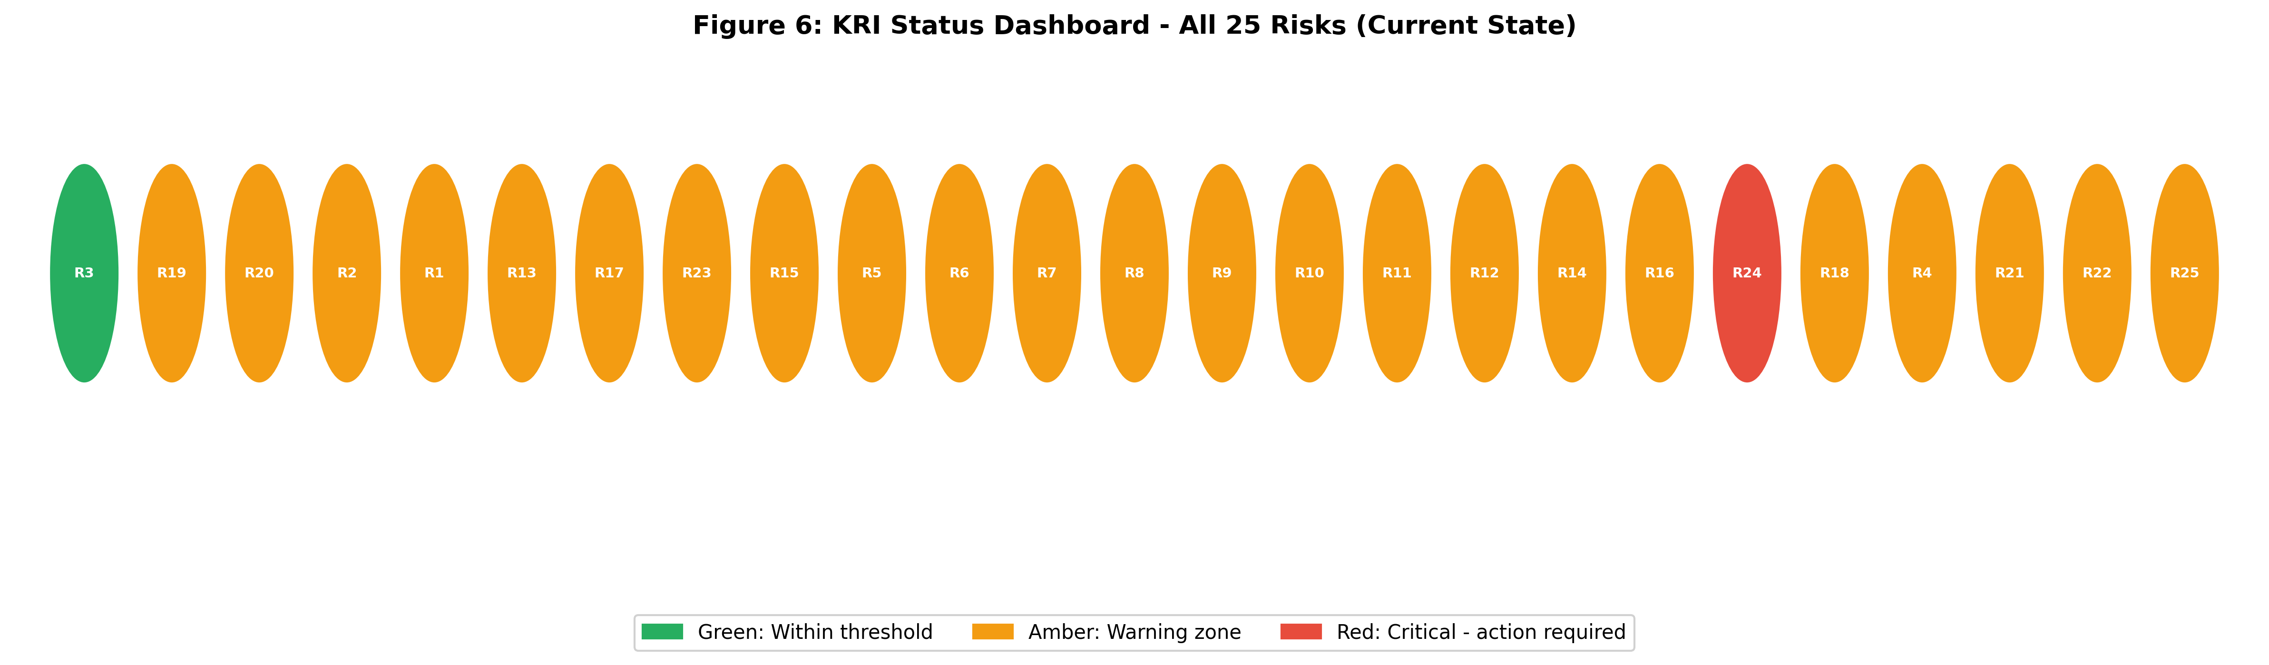
Figure 6: KRI Status Dashboard - Current State Across All 25 Risks (green = within threshold, amber = warning, red = critical)

9.2 Current KRI Status
The current KRI status across all 25 risks shows one Green indicator (R3 regulatory pipeline growth at 32% QoQ), one Red indicator (R24 multi-cloud redundancy at 42%, below the 50% Amber threshold), and 23 Amber indicators. The concentration of 23 risks in the Amber zone is the most important operational finding in this assessment. It means the portfolio is not in crisis, but it is operating with elevated risk across virtually every monitored dimension simultaneously. The ML model's escalation probability of 58.2% is consistent with this reading: the portfolio is in a high-caution state that requires active and sustained management attention, not emergency response.
The single Red KRI, R24 (multi-cloud redundancy at 42%), requires an immediate response. This risk was classified as Transfer in the response framework, but the Red status means the transfer mechanism (SLA strengthening) should be activated in parallel with a concrete timeline for increasing multi-cloud coverage above the 50% Amber threshold. This is an infrastructure architecture decision with a 6-12 month implementation horizon and should be prioritised in the current quarter's technology planning.

9.3 Feedback Loop and Re-Evaluation
Risk management is a continuous rather than one-time process. The KRI framework supports ongoing monitoring through monthly reporting for high-frequency metrics (win rate, platform uptime, open role fill rate) and quarterly reporting for slower-moving indicators (AI parity, regulatory pipeline growth, market share). The full risk register should be re-evaluated at the following trigger events: deal close in H2 2026; first post-integration quarterly earnings report; any competitor product announcement that materially changes the competitive landscape; and any regulatory enforcement action in CMMC, NIS2, CIRCIA, or HIPAA that shifts compliance buying urgency.

10. Final Recommendations
Based on the full enterprise risk assessment, six prioritized recommendations are offered to ServiceNow executive leadership.
First, treat AI capability parity as the highest-priority investment decision. R2 carries the highest individual impact score in the register and the ML model identifies AI parity as the second most influential predictor of portfolio escalation. The AI Capability Parity Index at 78% is 7 percentage points below the Green threshold of 85%. Closing this gap through accelerated R&D investment, strategic partnerships, or targeted AI capability acquisitions is the single action with the greatest effect on overall portfolio risk reduction. This decision requires board-level authorization and should be presented with a formal investment case within the current quarter.
Second, defend competitive positioning in vertical markets during the integration window. The 2026 enterprise budget cycle is the most vulnerable period for competitive displacement. Win rate at 31% is approaching the Red threshold, and the Strategic category carries a 99.7% probability of net loss. Prioritising differentiated use cases in manufacturing, healthcare, and energy, where rivals have demonstrably weaker OT depth, concentrates resources where the competitive advantage is most defensible. Monthly CRM win/loss analysis should begin immediately to provide early warning before deal losses appear in quarterly revenue.
Third, activate the R24 Red-status response in the current quarter. Multi-cloud redundancy at 42% is the only Red KRI in the current register. A concrete 12-month plan to bring multi-cloud coverage above 80% should be scoped, resourced, and approved in Q2 2026. In parallel, SLA renegotiations with primary cloud providers should be initiated to transfer financial liability for downtime events.
Fourth, build compliance-specific go-to-market infrastructure before competitors replicate existing certifications. The regulatory opportunity (R3) currently generates the highest expected upside in the portfolio (+$199.0 million). FedRAMP, DISA IL5, and KLAS certifications provide a durable competitive moat, but this moat narrows as competitors complete their own authorization processes. Dedicated compliance solution bundles, federal and healthcare sales team expansion, and regulatory trigger-based pipeline development should be treated as an offensive investment program, not a passive response to inbound demand.
Fifth, establish a dedicated Armis integration program office to address the operational root cause. The Operational and Technical category portfolios combined carry approximately -$74.5 million in expected annual loss with near-certain probability of negative impact. These losses reflect structural integration complexity that is not addressable through business strategy but through execution discipline. A ring-fenced integration PMO with dedicated engineering teams, clear milestone accountability, and authority to escalate resource conflicts would directly reduce the probability of the integration delays that drive R6, R7, R9, R10, and R11.
Sixth, frame R5 (Acquisition Overvaluation) as the financial performance monitoring framework rather than a risk to mitigate. The $7.75 billion acquisition price cannot be changed and neither mitigation nor transfer is viable. The appropriate response is active acceptance with defined performance milestones: quarterly cross-sell adoption tracking against a target adoption rate of 20% within 24 months of deal close; bi-annual goodwill impairment assessment against the growth assumptions embedded in the acquisition model; and a board-level review process that activates if cross-sell adoption falls below 10% at the 18-month mark.

11. Conclusion
This enterprise risk assessment evaluates all 25 identified risks associated with ServiceNow's $7.75 billion acquisition of Armis using an integrated qualitative and quantitative analytical framework. The central quantitative finding is that the full enterprise risk landscape produces a net expected annual portfolio impact of -$163.7 million with an 81.3% probability of net loss, representing a fundamentally different risk picture from the three-risk analysis conducted in earlier modules. The positive portfolio mean in the three-risk model (+$48.8 million) reflected the dominance of the regulatory opportunity over a limited downside set. When the complete set of strategic, operational, financial, technical, and market risks is included, the aggregate downside of -$514.3 million in expected negative impacts substantially exceeds the +$350.8 million in expected positive impacts.
The ML-based escalation model confirms that the current portfolio state, characterized by 23 of 25 KRIs in Amber and one in Red, places the portfolio at a 58.2% escalation probability. The two most influential predictors of escalation are competitive win rate and AI capability parity, providing direct prioritization guidance for management resource allocation. R24's Red KRI status for multi-cloud redundancy requires immediate action in the current quarter regardless of broader portfolio priorities.
The acquisition's strategic logic remains sound: the combined ServiceNow-Armis platform addresses a genuinely growing market, holds certifications that competitors cannot quickly replicate, and has regulatory tailwinds that are non-discretionary in nature. However, the quantitative evidence confirms that realizing the upside requires disciplined execution across multiple simultaneous risk dimensions. The six recommendations in Section 10 are not optional governance measures; they are the execution program through which the $7.75 billion investment either creates adequate shareholder returns or fails to justify its premium. Management attention concentrated on AI parity, competitive win rate defense, regulatory pipeline capture, and integration execution governance will determine the outcome.
The central implication of this analysis is that risk management is not a supporting function but a primary value driver in large-scale acquisitions. The $7.75 billion investment in Armis will succeed or fail not based on strategic intent alone, but on the disciplined execution of quantitatively informed risk responses. The KRI framework, Monte Carlo simulation, and ML escalation model developed in this assessment provide the analytical infrastructure to detect deterioration before it becomes visible in financial results. This positions enterprise risk analytics not as a governance requirement, but as a core mechanism of shareholder value creation.

References
Armis. (2025a, December 23). Armis to join ServiceNow: Strengthening our mission to protect our customers' most critical environments and reduce cyber risk at scale. Armis Blog. https://www.armis.com/blog/armis-to-join-servicenow/
Armis. (2025b, August 4). Armis surpasses $300M ARR as demand for exposure management security soars. Armis Newsroom. https://www.armis.com/newsroom/press/armis-surpasses-300m-arr-as-demand-for-exposure-management-security-soars/
Fleisher, C. S., and Bensoussan, B. E. (2015). Business and competitive analysis: Effective application of new and classic methods (2nd ed.). FT Press.
Forrester Research. (2025). The state of cybersecurity spending 2025. https://www.forrester.com/research/cybersecurity/
Gartner. (2025). Forecast: Information security, worldwide, 2023-2028. https://www.gartner.com/en/newsroom/press-releases/2025-08-28-gartner-forecasts-global-information-security-spending-to-grow-15-percent-in-2025
Jalilvand, A., and Moorthy, S. (2023). Triangulating risk profile and risk assessment. Journal of Risk and Financial Management, 16(11), 473. https://doi.org/10.3390/jrfm16110473
Khadem, M., Piya, S., and Shamsuzzoha, A. (2018). Quantitative risk management in gas injection project. Journal of Industrial Engineering International, 14(3), 637-654. https://doi.org/10.1007/s40092-017-0243-5
MarketsandMarkets. (2025). Operational Technology (OT) security market global forecast to 2030. https://www.marketsandmarkets.com/Market-Reports/operational-technology-ot-security-market-18524133.html
Palmer, A. (2025, December 23). ServiceNow acquiring cybersecurity startup Armis for nearly $8 billion. CNBC. https://www.cnbc.com/2025/12/23/servicenow-armis-cybersecurity-acquisition.html
ServiceNow. (2025a, December 23). ServiceNow to acquire Armis to expand cyber exposure and security across the full attack surface. ServiceNow Newsroom. https://newsroom.servicenow.com/
ServiceNow. (2026, January 29). ServiceNow reports fourth quarter and full-year 2025 financial results. ServiceNow Investor Relations. https://newsroom.servicenow.com/

Appendix 1: Complete Risk Treatment and Response Plan
The Risk Treatment and Response Plan (RT&RP) consolidates the quantitative assessment outputs, KRI current status, response strategies, escalation triggers, and risk owners in a single reference table for management use. This plan has been updated iteratively across Modules 2 through 6 and represents the final integrated state of the enterprise risk assessment.
ID | Risk | L/I | Score | MC Expected | 90% CI | KRI Status | Strategy | Priority | Escalation Trigger
R3 | Regulatory Demand Acceleration | 9/8 | 72 | +$199.0M | -$71.7M to +$262.9M | Green | Exploit | HIGH | Pipeline growth <10% QoQ
R19 | OT/IoT Market Growth | 7/8 | 56 | +$81.7M | -$2.1M to +$268.6M | Amber | Exploit | HIGH | Share gain <5% YoY
R20 | Cross-Sell Revenue | 7/8 | 56 | +$71.2M | -$2.1M to +$268.6M | Amber | Enhance | HIGH | Adoption rate <10%
R2 | AI Platform Convergence | 7/9 | 63 | -$84.0M | -$140M to -$40M | Amber | Escalate | HIGH | AI parity <70%
R1 | Competitive Displacement | 7/8 | 56 | -$65.3M | -$105M to -$30M | Amber | Mitigate | HIGH | Win rate <25%
R13 | AI Technology Obsolescence | 7/8 | 56 | -$54.8M | -$105M to -$30M | Amber | Mitigate | HIGH | Feature parity <75%
R17 | Customer Migration | 7/8 | 56 | -$50.2M | -$105M to -$30M | Amber | Mitigate | HIGH | Retention <90%
R23 | AI Governance Risk | 5/9 | 45 | -$41.7M | -$217.8M to +$0M | Amber | Mitigate | HIGH | Maturity <60%
R15 | Legal Compliance Liability | 7/6 | 42 | -$30.3M | -$73.2M to -$2.0M | Amber | Transfer | MEDIUM | Audit pass rate <75%
R5 | Acquisition Overvaluation | 5/8 | 40 | -$75.0M | -$217.8M to +$0M | Amber | Accept | MEDIUM | Synergy targets miss >40%
R6 | Integration Overload | 5/6 | 30 | -$10.8M | -$73.2M to -$2.0M | Amber | Mitigate | MEDIUM | Milestones <70% on schedule
R7 | Architecture Incompatibility | 5/6 | 30 | -$10.8M | -$71.6M to -$4.4M | Amber | Mitigate | MEDIUM | Sync error rate >5%
R8 | Talent Shortage | 5/6 | 30 | -$9.7M | -$73.2M to -$2.0M | Amber | Transfer | MEDIUM | Fill rate <60%
R9 | Organisational Disruption | 5/6 | 30 | -$9.7M | -$73.2M to -$2.0M | Amber | Mitigate | MEDIUM | Retention <80% at 12 months
R10 | Data Accuracy Gaps | 5/6 | 30 | -$6.7M | -$71.6M to -$4.4M | Amber | Mitigate | MEDIUM | Accuracy <95%
R11 | Infrastructure Instability | 5/6 | 30 | -$6.7M | -$73.2M to -$2.0M | Amber | Mitigate | MEDIUM | Uptime <98%
R12 | Security Vulnerabilities | 5/6 | 30 | -$10.8M | -$71.6M to -$4.4M | Amber | Transfer | MEDIUM | Security score <70
R14 | Regulatory Complexity | 5/6 | 30 | -$6.7M | -$73.2M to -$2.0M | Amber | Mitigate | MEDIUM | Coverage <85%
R16 | Cloud Cost Expansion | 5/6 | 30 | -$10.8M | -$217.8M to +$0M | Amber | Mitigate | MEDIUM | Cloud cost >12% of revenue
R24 | Cloud Dependency | 5/6 | 30 | -$6.7M | -$71.6M to -$4.4M | Red | Transfer | MEDIUM | Multi-cloud <50%
R18 | Economic Slowdown | 5/6 | 30 | -$10.8M | -$2.1M to +$268.6M | Amber | Accept | MEDIUM | Conversion rate <15%
R4 | Market Consolidation | 5/6 | 30 | -$9.7M | -$2.1M to +$268.6M | Amber | Accept | MEDIUM | Market share <8%
R21 | Workflow Misalignment | 3/4 | 12 | -$0.75M | -$73.2M to -$2.0M | Amber | Accept | LOW | Alignment <70%
R22 | Customer Uncertainty | 3/2 | 6 | -$0.60M | -$2.1M to +$268.6M | Amber | Accept | LOW | CSAT <3.5
R25 | Vendor Lock-In | 3/6 | 18 | -$1.80M | -$71.6M to -$4.4M | Amber | Accept | LOW | Open standards <50%
Table A1: Complete Risk Treatment and Response Plan - All 25 Risks (Final)
GitHub Repository: https://github.com/ALY6130-Risk-Management-Group4
All analysis code, notebooks, Excel workbooks, and processed data outputs supporting this report are available in the project repository organized as: enterprise-risk-project/data/raw/, enterprise-risk-project/data/processed/, enterprise-risk-project/notebooks/, and enterprise-risk-project/report/. The Python script enterprise_risk_analysis.py produces all quantitative outputs with seed=42 for full reproducibility.

